

Analysis Using a Smart Supply Chain from DataCo

Supply Chain Analytics

(MGT3015) SLOT:- F1

**Team Members**

20MIA1016-DARSI VENKATA SAI MAHIDHAR

20MIA1019-KANAPARTHI ROSHIN SAI

20MIA1031-SANJAY.M

20MIA1039-SRIGANTH R

20MIA1117-PILLARAM MANOJ

## ABSTRACT:

The modern landscape of supply chain management has witnessed a profound transformation through the integration of Big Data Analysis into DataCo's SMART System. This advanced system harnesses a diverse dataset, including order details, inventory levels, production schedules, transportation data, weather conditions, market trends, and customer feedback. Through real-time analytics, artificial intelligence, and big data, the SMART System optimizes supply chain operations. This report delves into the architecture, techniques, and capabilities of the SMART System, with a specific focus on the application of machine learning, artificial intelligence, predictive analytics, and prescriptive analytics models. It also highlights the plan to leverage data visualizations using Tableau software. The core problem addressed is the imperative need for supply chain companies to monitor customer delivery performance to enhance customer satisfaction, boost productivity, and maintain market competitiveness.

## PROBLEM STATEMENT:

Supply chain company must prioritize monitoring customer delivery performance in order to improve customer satisfaction, optimize productivity, and maintain competitiveness in the market.

## INTRODUCTION:

Supply chain management plays a pivotal role in the success and competitiveness of businesses across various sectors in today's interconnected global corporate environment. The intricacies of managing a network of suppliers, manufacturers, distributors, and retailers necessitate precision, efficiency, and adaptability. The fusion of big data analytics with supply chain management has ushered in an era of data-driven decision-making in this dynamic landscape. The SMART System, with its intricate dataset, advanced architecture, and sophisticated approaches, lies at the heart of this revolution. It offers a comprehensive understanding of how raw data is processed into valuable insights, empowering organizations not only to respond swiftly to market changes but also to anticipate and manage supply chain challenges.

However, the adoption of the SMART System in a supply chain setting comes with its set of considerations. Businesses must carefully weigh the benefits against potential drawbacks associated with implementing cutting-edge technologies. While the system promises substantial advantages in terms of efficiency, cost savings, and improved decision-making, it presents challenges related to data security, integration, and the need for specialized personnel. Striking a balance between these benefits and potential drawbacks is essential to remain competitive in a constantly evolving market

## LITERATURE REVIEW:

The DataCo SMART (Supply Chain Management Analytics for Real-Time) system represents a cutting- edge approach to harnessing the power of big data analytics for optimizing supply chain operations. It relies on a diverse and constantly updated dataset, encompassing order details, inventory levels, production schedules, transportation data, weather conditions, market trends, and customer feedback. At its core, the SMART system employs a deep neural network-based machine learning model, combining recurrent and convolutional neural networks for tasks like time-series forecasting, anomaly detection, demand prediction, and route optimization. It offers real-time insights, improving efficiency, customer

satisfaction, and adaptability, all driven by data. However, it comes with challenges, such as data integration complexities, high computational requirements, ongoing model maintenance, data privacy concerns, and initial implementation costs. Future research should focus on scalability, explainability, sustainability, integration with emerging technologies, and benchmarking for broader industry applications.

This paper offers a comprehensive overview of predictive big data analytics techniques applied to supply chain demand forecasting, emphasizing the critical role of accurate forecasting in optimizing inventory management and enhancing customer satisfaction. The discussion covers diverse data sources for demand forecasting, modeling approaches, and key phases in the forecasting process. Various methods, including traditional time series analysis, machine learning, deep learning, Bayesian methods, and ensemble techniques, are explored for demand prediction. The pros of these techniques encompass enhanced accuracy, cost reduction, improved customer satisfaction, adaptability, and data-driven decision-making. On the downside, challenges include data quality, computational resource requirements, model complexity, implementation costs, and ongoing model maintenance.The paper also highlights significant research gaps in this field, which include uncertainty management, real-time analytics for dynamic environments, scalability for large-scale supply chains, integration with IoT data, sustainability considerations, and ethical issues related to data privacy and transparency. Addressing these research gaps is crucial for advancing the domain of predictive big data analytics for supply chain demand forecasting and meeting the evolving demands of modern supply chain management.

This research paper presents an in-depth exploration of predictive big data analytics techniques applied to supply chain demand forecasting, emphasizing the pivotal role of accurate forecasting in optimizing inventory management and enhancing customer satisfaction. The dataset used for demand forecasting comprises historical sales data, market trends, weather conditions, economic indicators, and customer behavior data, characterized by its significant size, heterogeneity, and frequent updates, rendering it suitable for big data analytics applications. The paper covers various modeling approaches, encompassing time series analysis, machine learning, deep learning, Bayesian methods, and ensemble techniques, tailored to accurately predict future demand.In the pros section, the paper highlights enhanced demand forecasting accuracy, cost reduction through optimized inventory management, improved customer satisfaction by ensuring product availability, adaptability to changing market dynamics, and informed decision-making based on data-driven insights. Conversely, in the cons section, challenges include potential inaccuracies due to poor data quality, computational resource requirements for advanced models, complexity and interpretability issues in certain models, initial implementation costs, and the ongoing need for model maintenance and updates.The research paper also identifies critical research opportunities in this field, including developing methods to quantify and manage uncertainty in forecasts, real-time analytics to address rapidly changing supply chain environments, scalable solutions for large-scale supply chain networks, the integration of IoT data to enhance forecasting, investigating sustainability aspects of predictive analytics, and addressing ethical issues related to data privacy and transparency in supply chain analytics. These research areas are pivotal for advancing the realm of predictive big data analytics for supply chain demand forecasting.

Real-time prediction models in supply chain management encompass essential stages like data preprocessing, feature engineering, model training, validation, and prediction. These models are designed to deliver real-time forecasts and insights, ultimately optimizing supply chain operations.The benefits of such models include improved demand forecasting accuracy, heightened responsiveness to market changes and disruptions, cost reduction through optimized inventory and transportation operations, increased customer satisfaction, and data-driven decision-making. However, challenges like data quality issues, computational resource requirements, model complexity, initial implementation costs, and the need for ongoing model maintenance must be considered.Furthermore, critical research gaps in the domain of real-time prediction models for supply chain management include developing methods to manage uncertainty in real-time predictions, investigating scalability for large-scale supply chain networks, exploring the integration of IoT data for enhanced real-time predictions, addressing ethical concerns related to data privacy and transparency, and establishing standardized benchmarks for assessing the effectiveness of real-time prediction models across diverse industries and domains. These research areas are essential for advancing the field of real-time prediction in supply chain management.

This systematic literature review delves into the role of Big Data Analytics (BDA) in Supply Chain Management (SCM). It synthesizes a substantial body of literature spanning several years, shedding light on key findings and outlining future research directions in this domain. The analysis explores the wide array of data sources used in BDA for SCM, the various models and approaches employed, as well as the advantages and disadvantages of integrating BDA into SCM.BDA in Supply Chain Management leverages a diverse set of datasets from sources like order data, inventory levels, transportation data, weather conditions, market trends, and customer feedback. These datasets are often characterized by their size, unstructured nature, and dynamism, necessitating advanced data preprocessing and purification techniques. To manage and analyze this vast data, BDA deploys technologies and methods such as data warehousing, data lakes, and cloud-based platforms.The models utilized in BDA for SCM are multifaceted and tailored to specific SCM objectives.

These include Predictive Analytics, Prescriptive Analytics, Machine Learning, and Artificial Intelligence models. Predictive models estimate demand and anticipate market trends, while prescriptive models recommend optimal actions. Machine Learning and AI models automate processes and enhance decision-making through pattern recognition and anomaly detection.Pros of integrating BDA in SCM encompass enhanced decision-making, streamlined processes, improved demand forecasting, early disruption identification, and a competitive edge through data-driven strategies. However, challenges include the management of large and diverse datasets, data security concerns, the need for specialized skills, infrastructure costs, and the complexity of integrating BDA systems with existing SCM setups.In the systematic literature review, a significant research gap is identified, primarily related to the limited focus on practical implementation and real-world case studies. While there is extensive discussion about the theoretical potential of BDA in SCM, empirical studies and practical insights illustrating successful BDA implementation in various supply chain contexts are notably lacking. Bridging this gap with comprehensive case studies is crucial to provide organizations considering BDA adoption in their supply chain processes with valuable insights and real-world examples.

## DATASET DESCRIPTION:

The SMART system relies on a diverse dataset collected from various sources within the supply chain. This dataset includes information such as order details, inventory levels, production schedules, transportation data, weather conditions, market trends, and customer feedback. The dataset is extensive and is updated in real-time, allowing for the most up-to-date analysis of supply chain operations.

**Type : Type of transaction made**

**Days for shipping (real) : Actual shipping days of the purchased product**

**Days for shipment (scheduled) : Days of scheduled delivery of the purchased product**

**Benefit per order : Earnings per order placed**

**Sales per customer : Total sales per customer made per customer**

**Delivery Status : Delivery status of orders: Advance shipping , Late delivery , Shipping canceled , Shipping on time**

**Late_delivery_risk : Categorical variable that indicates if sending is late (1), it is not late (0).**

**Category Id : Product category code**

**Category Name : Description of the product category**

**Customer City : City where the customer made the purchase**

**Customer Country : Country where the customer made the purchase**

**Customer Email : Customer's email**

**Customer Fname : Customer name**

**Customer Id : Customer ID**

**Customer Lname : Customer lastname**

**Customer Password : Masked customer key**

**Customer Segment : Types of Customers: Consumer , Corporate , Home Office**

**Customer State : State to which the store where the purchase is registered belongs**

**Customer Street : Street to which the store where the purchase is registered belongs**

**Customer Zipcode : Customer Zipcode**

**Department Id : Department code of store**

**Department Name : Department name of store**

**Latitude : Latitude corresponding to location of store**

**Longitude : Longitude corresponding to location of store**

**Market : Market to where the order is delivered : Africa , Europe , LATAM , Pacific Asia , USCA**

**Order City : Destination city of the order**

**Order Country : Destination country of the order**

**Order Customer Id : Customer order code**

**order date (DateOrders) : Date on which the order is made**

**Order Id : Order code**

**Order Item Cardprod Id : Product code generated through the RFID reader**

**Order Item Discount : Order item discount value**

**Order Item Discount Rate : Order item discount percentage**

**Order Item Id : Order item code**

**Order Item Product Price : Price of products without discount**

**Order Item Profit Ratio : Order Item Profit Ratio**

**Order Item Quantity : Number of products per order**

**Sales : Value in sales**

**Order Item Total : Total amount per order**

**Order Profit Per Order : Order Profit Per Order**

**Order Region : Region of the world where the order is delivered : Southeast Asia ,South Asia ,Oceania ,Eastern Asia, West Asia , West of USA , US Center , West Africa, Central Africa ,North Africa ,Western Europe ,Northern , Caribbean , South America ,East Africa ,Southern Europe , East of USA ,Canada ,Southern Africa , Central Asia , Europe , Central America, Eastern Europe , South of USA**

**Order State : State of the region where the order is delivered**

**Order Status : Order Status : COMPLETE , PENDING , CLOSED , PENDING_PAYMENT ,CANCELED , PROCESSING ,SUSPECTED_FRAUD ,ON_HOLD ,PAYMENT_REVIEW**

**Product Card Id : Product code**

**Product Category Id : Product category code**

**Product Description : Product Description**

**Product Image : Link of visit and purchase of the product**

**Product Name : Product Name**

**Product Price : Product Price**

**Product Status : Status of the product stock :If it is 1 not available , 0 the product is available**

**Shipping date (DateOrders) : Exact date and time of shipment**

**Shipping Mode : The following shipping modes are presented : Standard Class , First Class , Second Class , Same Day**

# Results and Discussion:

# 

The graph shows the sales trend for the company, with the x-axis representing the quarter of the order date and the y-axis representing the sales. The highest sales were in Q3 2017, followed by Q4 2015, Q4 2016, and Q2 2023. The lowest sales were in Q2 2017.

The main understanding of the graph is that sales have been increasing over time. There was a dip in sales in Q1 2016, but it is unclear whether this is a seasonal trend or a one-off event.

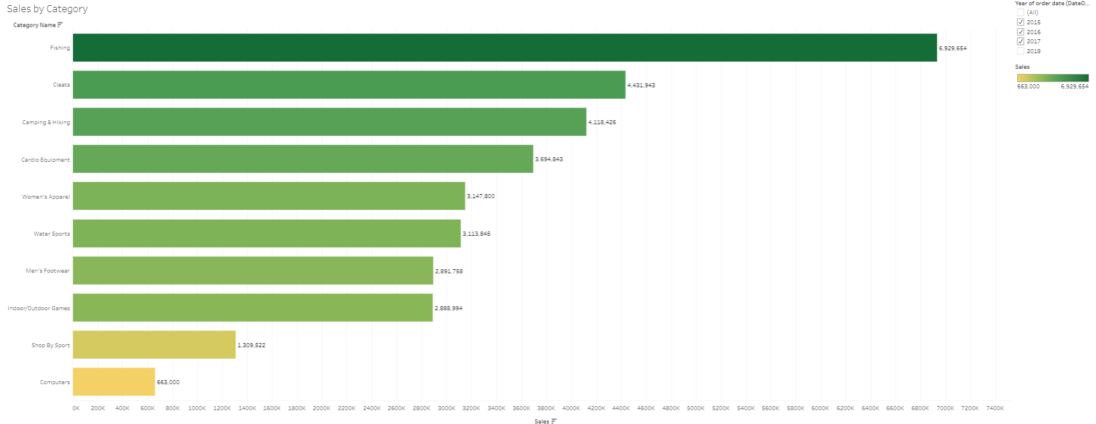

The graph shows the sales by category for the company, with the x-axis representing the sales and the y-axis representing the category name. The highest sales are for fishing, followed by cleats, camping & hiking, and cardio Equipment. The lowest sales are for computers.

The main understanding of the graph is that the company's sales are concentrated in a few categories. Fishing accounts for over half of the company's sales, and cleats, camping & hiking, and cardio Equipment account for the remainder.

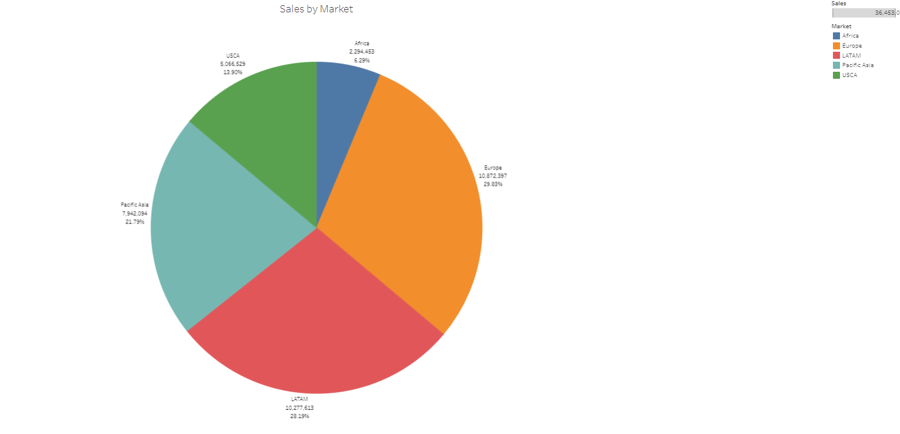

The pie chart shows the sales by market for a company. The highest sales are in the Europe, at 29.83%. The lowest sales are in the Africa, at 6.29%. The other markets are LATAM (28.19%), Pacific asia (21.79%), and USCA (13.90%).

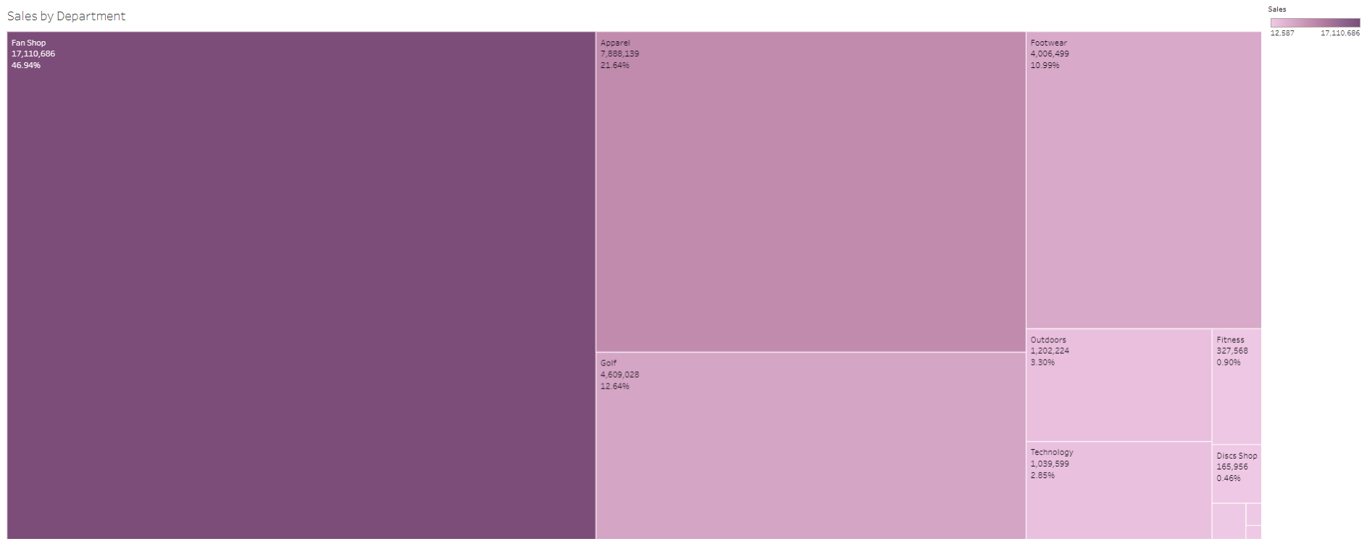

The graph shows the sales by department for a company, with the x-axis representing the department name and the y-axis representing the percentage of total sales. The highest sales are for the Fan Shop, at 46.94% of total sales. The lowest sales are for the Disc shop, at 0.46% of total sales.

The main understanding of the graph is that the company's sales are concentrated in a few departments. The Fan shop accounts for the highest percentage of sales, followed by the Apparel (21.64%), Golf (12.64%), and Footwear (10.99%). The other departments account for less than 10% of sales each.

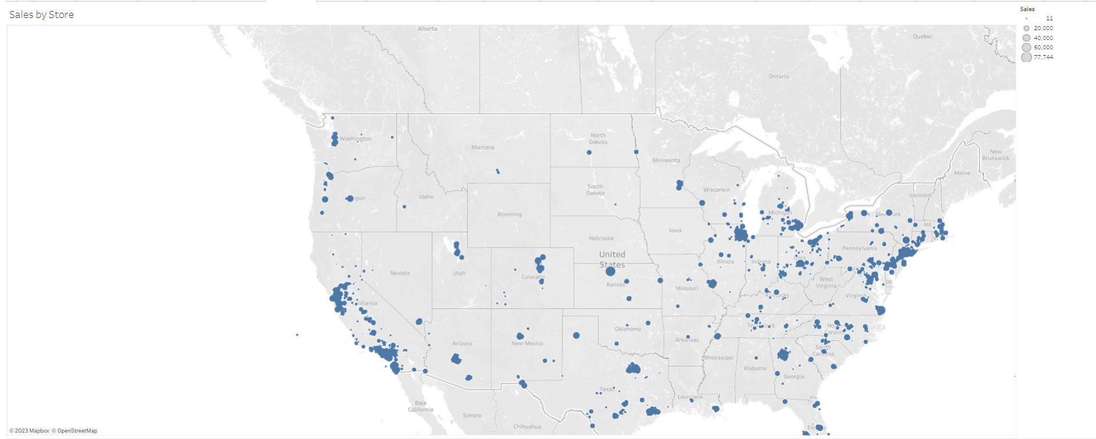

The above graph is a scatter plot of the sales for each store in a chain, with the x-axis representing the latitude of the store and the y-axis representing the longitude of the store. The size of the bubble represents the sales for that store.

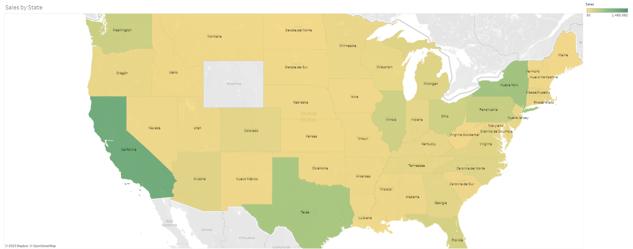

The above graph is a map of the United States, with each state colored differently to represent sales. The states with the highest sales are California, Texas, and New York. The states with the lowest sales are Wyoming, North Dakota, and South Dakota.

The main understanding of the graph is that sales are concentrated in a few states. The top three states account for over 25% of total sales. The bottom three states account for less than 2% of total sales.

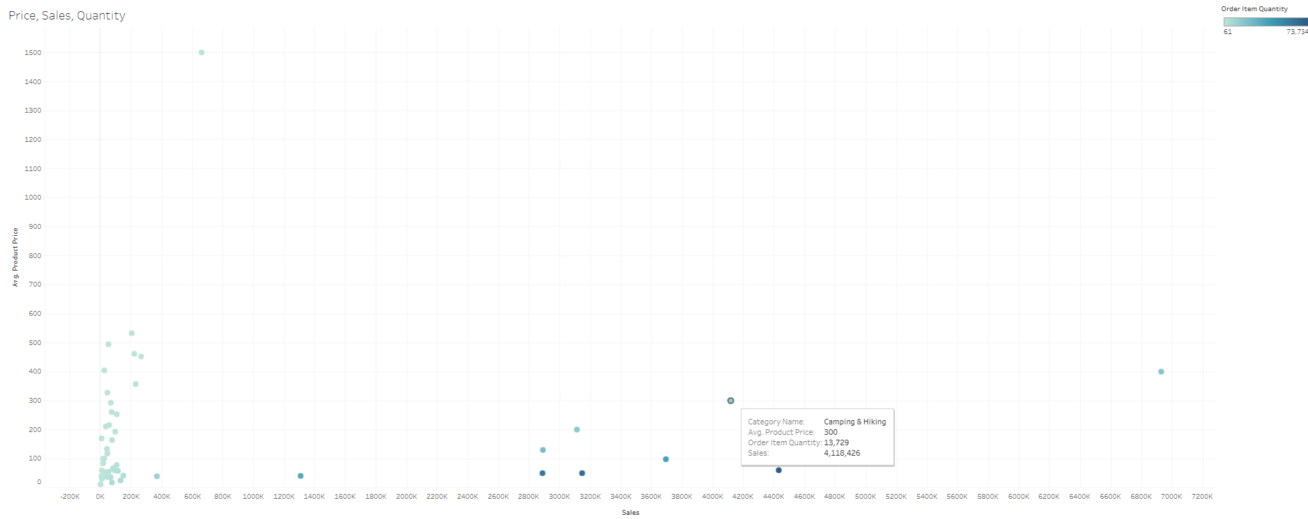

A scatter plot of the sales for each category, with the x-axis representing the sales and the y-axis representing the average product price. The size of the bubble represents the quantity of orders placed for that category. The highest average product price is for the category with the lowest sales. This suggests that this category may be selling high-priced items to a small number of customers.The lowest average product price is for the category with the highest sales. This suggests that this category may be selling low-priced items to a large number of customers. The main understanding of the graph is that there is a negative correlation between sales and average product price. This means that as the average product price increases, sales tend to decrease.

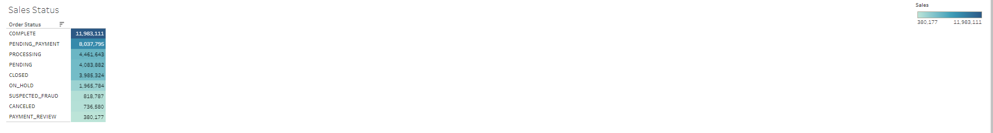

The graph show that sales are highest for orders that are completed. Orders that are in the "Shipped" status are most likely to be completed, as they have already been shipped to the customer. Orders that are in the "Cancelled" status are least likely to be completed, as they have been cancelled by the customer.

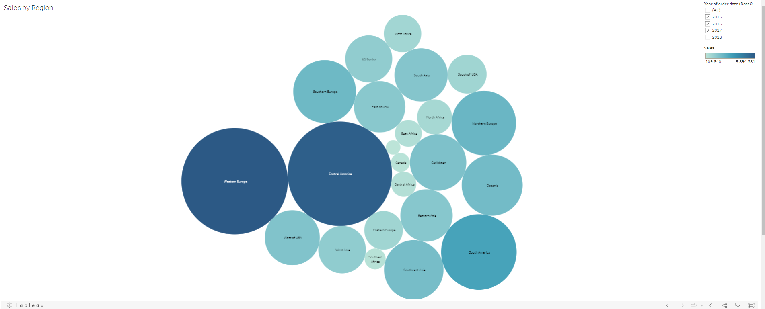

The graph shows the sales by region for a company, with the x-axis representing the order region and the y-axis representing the sales. The highest sales are for the Western Europe, at 5,894,381. The lowest sales are for the central asia, at 109,840. The main understanding of the graph is that the company is heavily reliant on the Europe and US market for its sales. The Europe and US market accounts for over half of the company's total sales. The other markets are relatively small by comparison.

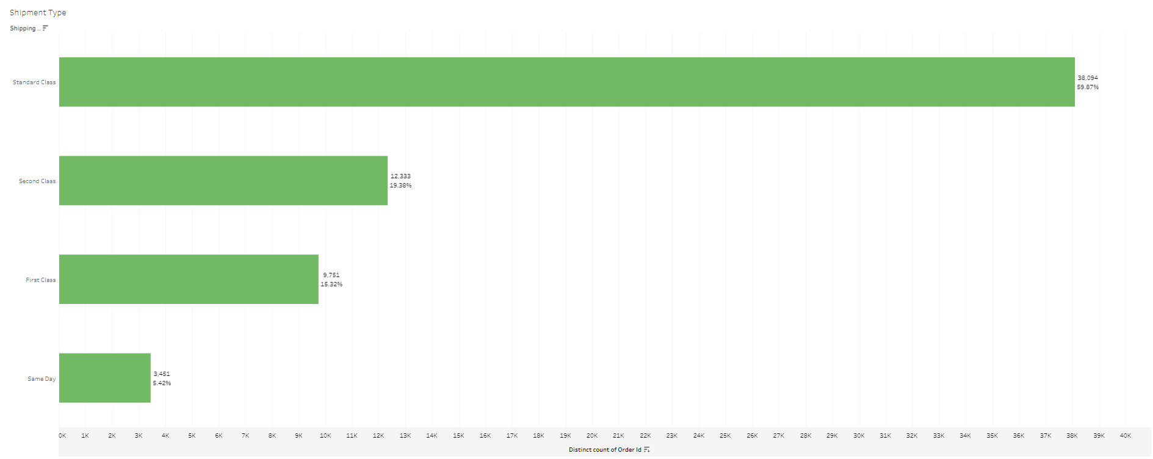

The graph shows the number of shipments for each shipment type, with the x-axis representing the distinct count of order ID and the y-axis representing the number of shipments. The highest number of shipments is for the "Standard class" shipment type, followed by the "Second class" shipment type. The lowest number of shipments is for the "Sameday" shipment type.

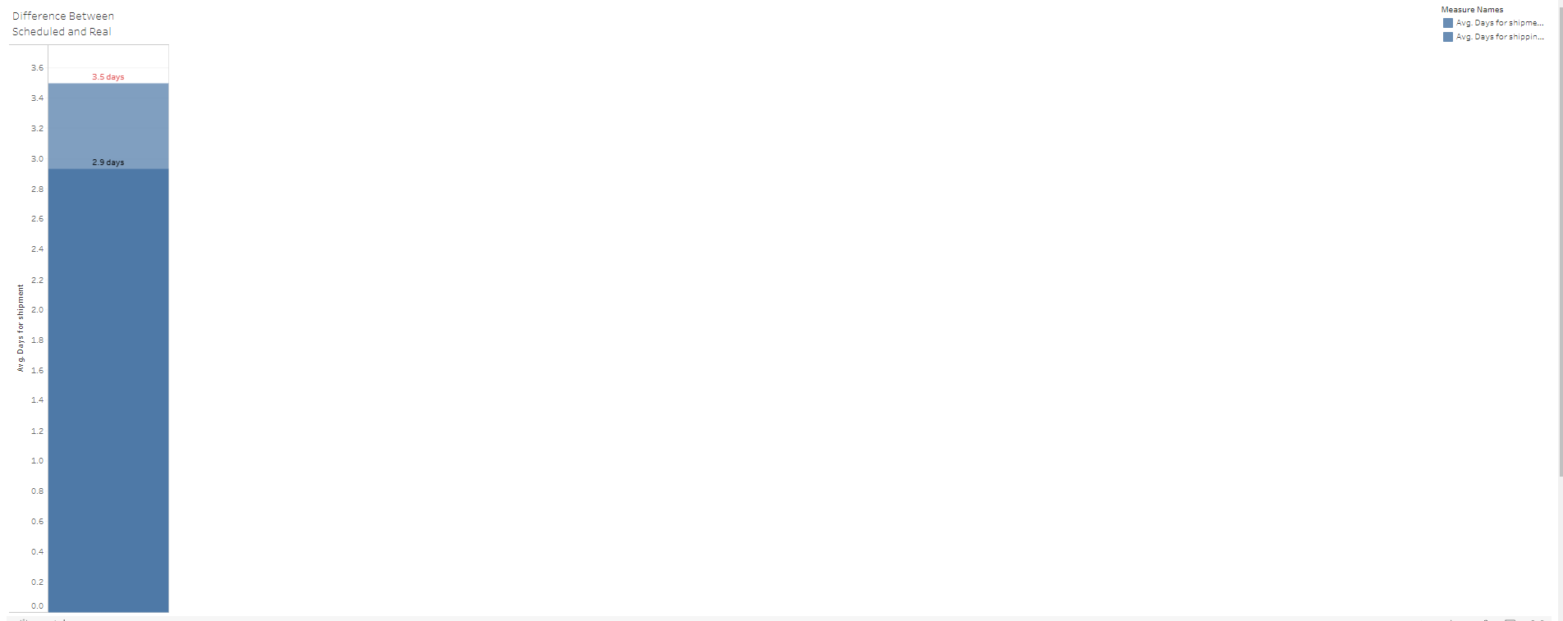

From the graph, we can understand that the average number of days of shipping is higher than the scheduled number of days. This means that it is taking longer than expected to ship orders. The highest difference between scheduled and real days of shipping is 3.5 days. This means that some orders are taking 7 days longer to ship than expected. The lowest difference between scheduled and real days of shipping is 0 days. This means that some orders are being shipped on time. The main understanding of the graph is that the company is having difficulty meeting its shipping schedules. This could be due to a number of factors, such as high order volume, staffing shortages, or supply chain disruptions. The company should investigate the reasons for the delays and take steps to address them. For example, the company could hire more staff, invest in new equipment, or partner with new suppliers.

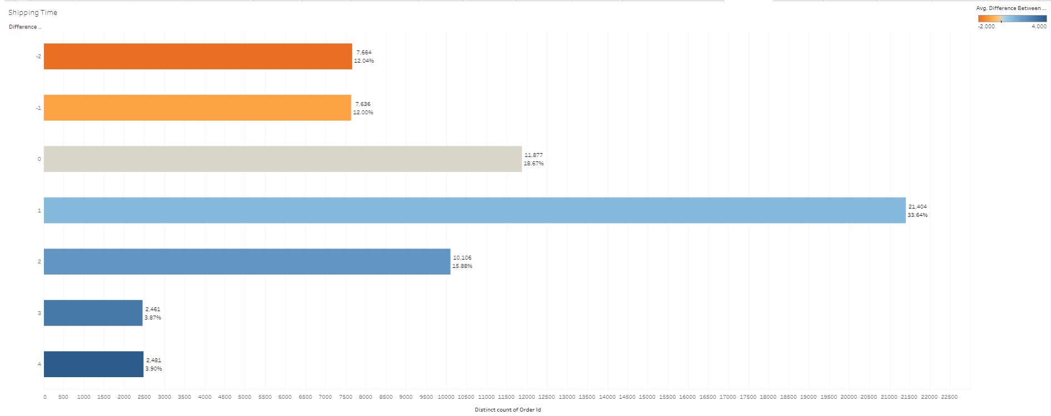

From the graph, we can understand that the highest difference in shipment time is 4 days, and the lowest difference is -2 days in a few cases. This graph shows the difference in shipment time for orders in the dataset. The x-axis represents the number of distinct orders, which is a unique identifier for each order in the dataset. The y-axis represents the difference in shipment time in days.

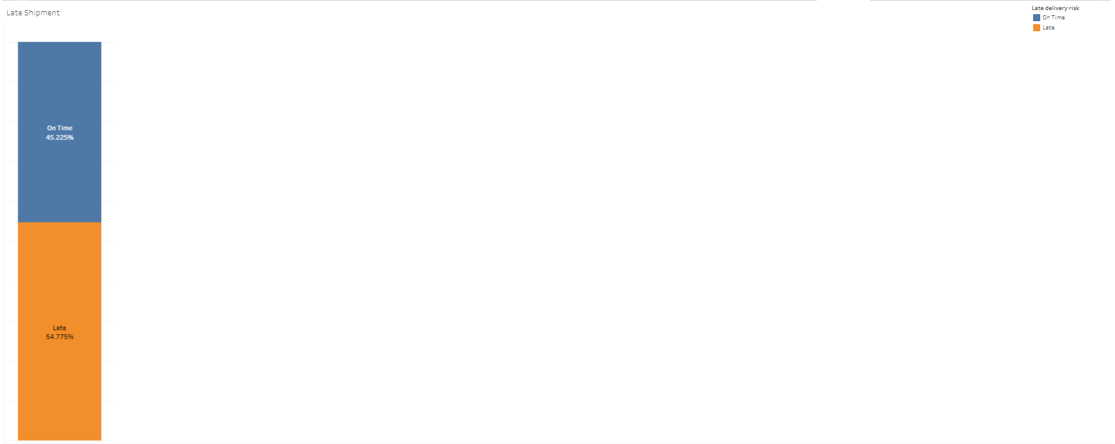

The graph shows the percentage of late shipments over time. The x-axis represents the date, and the y-axis represents the percentage of late shipments. The percentage of late shipments is 54.77%, and the percentage of on time shipments is 45.22%.

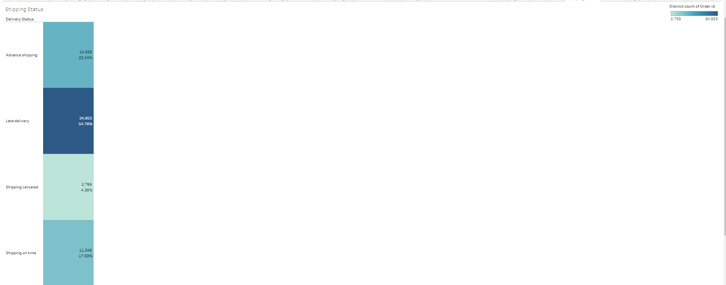

The graph shows the percentage of orders with each delivery status, with the x-axis representing the delivery status and the y-axis representing the percentage of total distinct count of order ID. The highest percentage is for the "Late delivery" status, at 54.78%. The lowest percentage is for the "Shippping Cancelled" status, at 4.35%. There is a small percentage of orders that are cancelled.

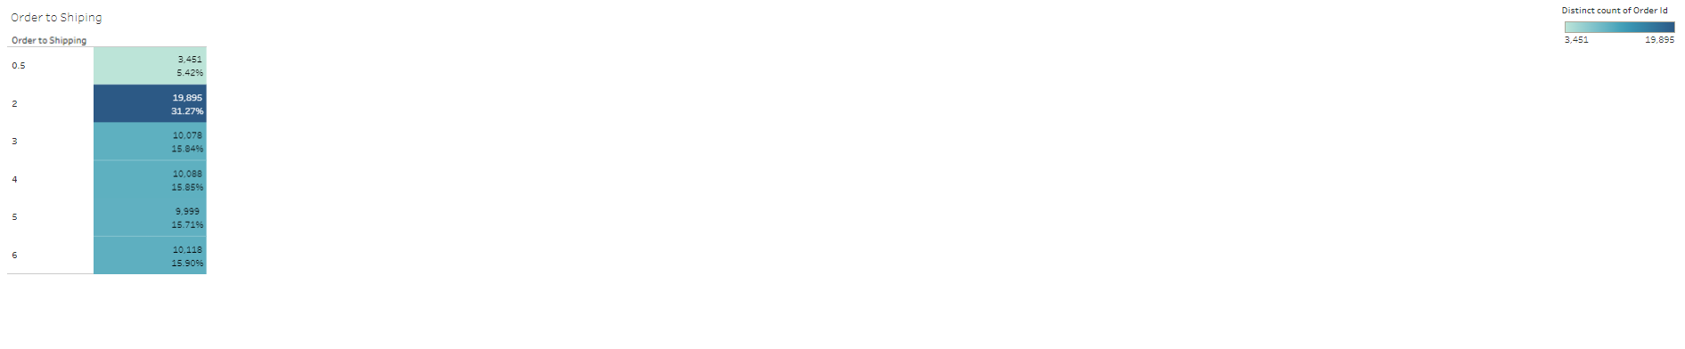

The graph shows the percentage of orders that are shipped within a certain number of days of being placed. The x-axis represents the order-to-shipping time in days, and the y-axis represents the percentage of total distinct count of order ID. The highest percentage is for the 2-day order-to-shipping time, at 31.27%. The lowest percentage is for the 6-day order-to-shipping time, at 15%. The main understanding of the graph is that the majority of orders are shipped within 1-3 days of being placed. However, there is a small percentage of orders that take longer to ship.

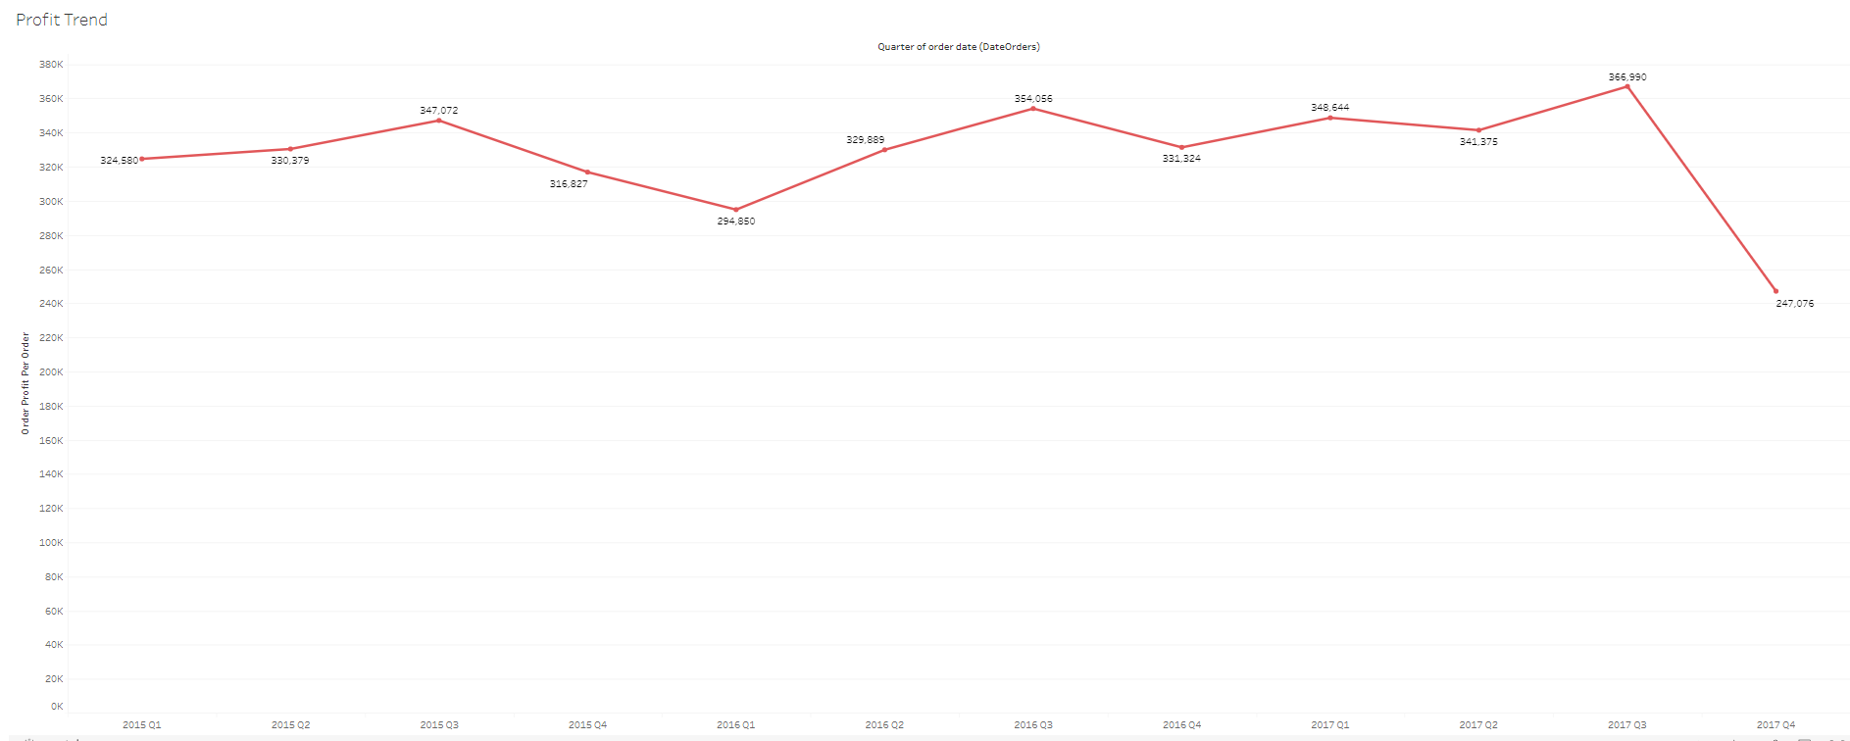

The graph shows the profit trend over time, with the x-axis representing the quarter of the order date and the y-axis representing the order profit per order. The highest profit per order is in Q3(2017), at 366,990, and the lowest profit per order is in Q4(2017), at 247,076. The main understanding of the graph is that the company's profit per order is highest in Q3 and lowest in Q4. This could be due to a number of factors, such as seasonal fluctuations in demand, changes in marketing and advertising spend, or changes in costs.

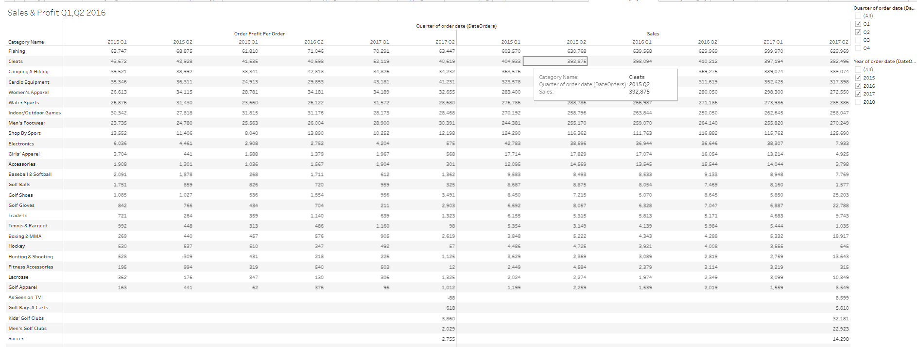

The graph shows the sales and profit for the first two quarters of 2016, by category. The x-axis represents the quarter of the order date and the y-axis represents the category name. The bars are colored blue for sales and orange for profit. The main understanding of the graph is that the Fishing category is the most profitable category for the company. The Fishing category also has the highest sales, but the sales margin (profit as a percentage of sales) is likely higher for the Fishing category than for the other categories.

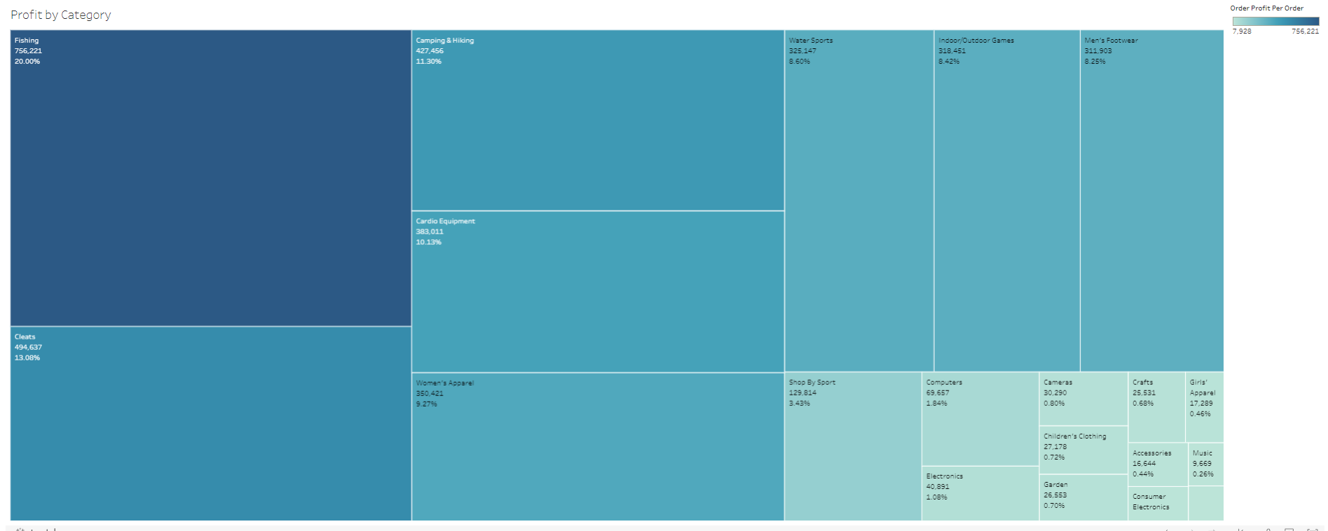

The graph shows the profit by category, with the x-axis representing the category name and the y-axis representing the percentage of total order profit per order and order profit per order. The highest percentage of total order profit per order is for the Fishing, at 20%. The lowest percentage of total order profit per order is for the women’s Clothing category, at 0.21%. The highest order profit per order is for the Fishing category, at 756,221. The lowest order profit per order is for the women’s Clothing category, at 7,928. The main understanding of the graph is that the Electronics category is the most profitable category for the company. The Fishing category accounts for 20% of the company's total order profit, even though it only accounts for 756,221 of the company's total orders. This means that the Fishing category has a higher profit margin than the other categories.

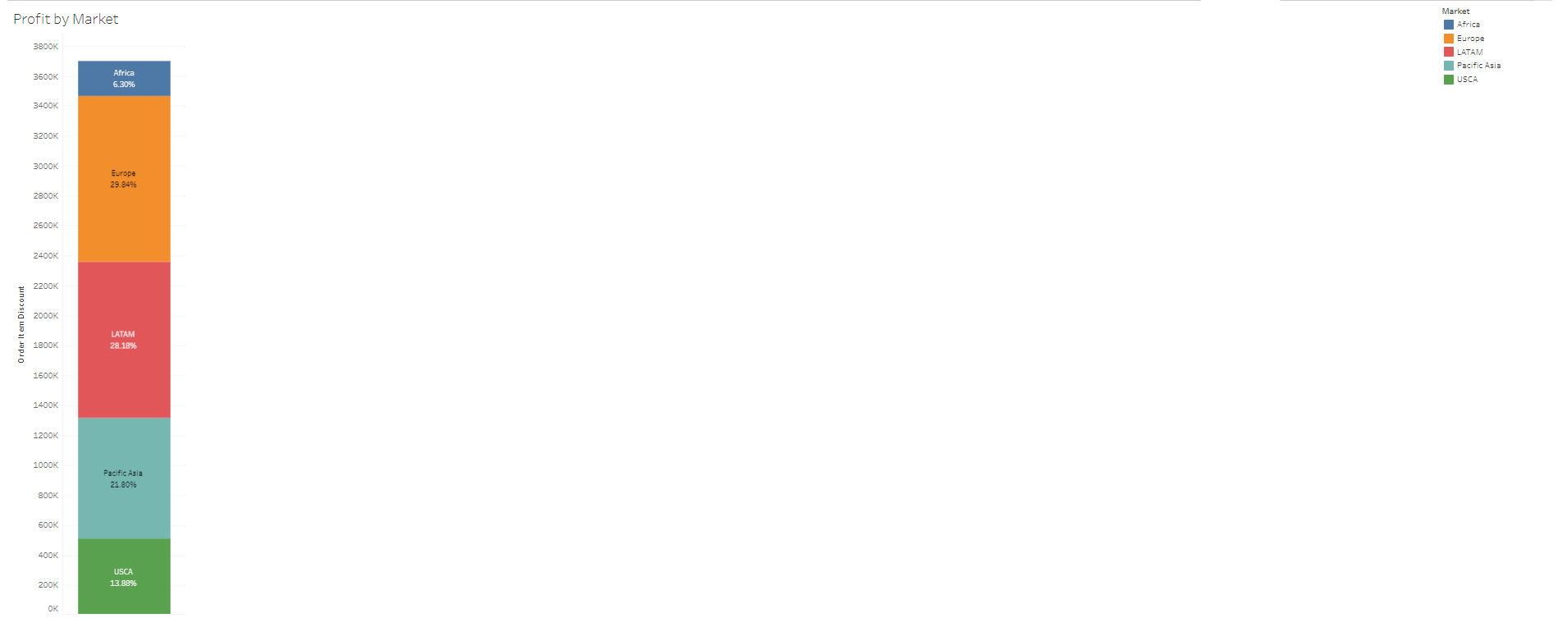

The graph shows the profit by market, with the x-axis representing the market and the y-axis representing the percentage of total order item discount along table and order item discount. The highest percentage of total order item discount is for the Europe market, at 29.84%. The lowest percentage of total order item discount is for the Africa market, at 6.30%. The highest order item discount is for the Europe market, at 1,103,211. The lowest order item discount is for the Asia Pacific market, at 232,775.

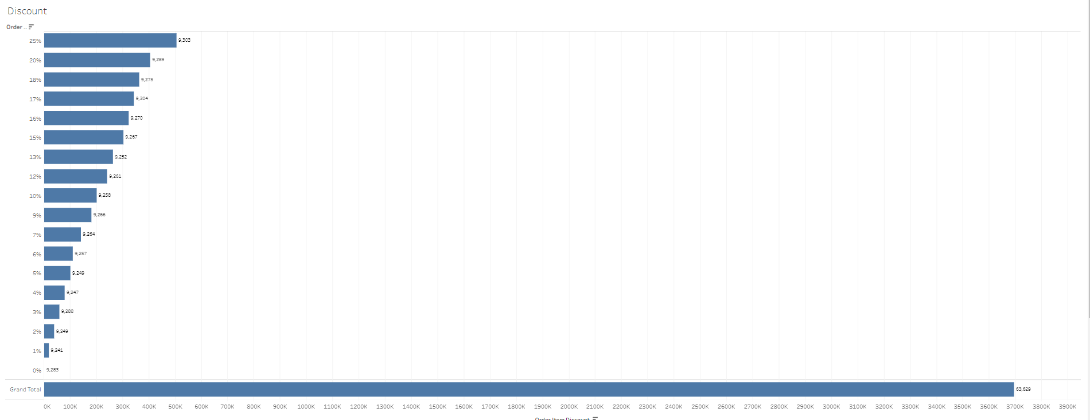

The graph shows the distribution of discounts for orders. The x-axis represents the order item discount and the y-axis represents the number of orders. The highest number of orders is for the 25% discount, followed by the 20% discount. The lowest number of orders is for the 0% discount.

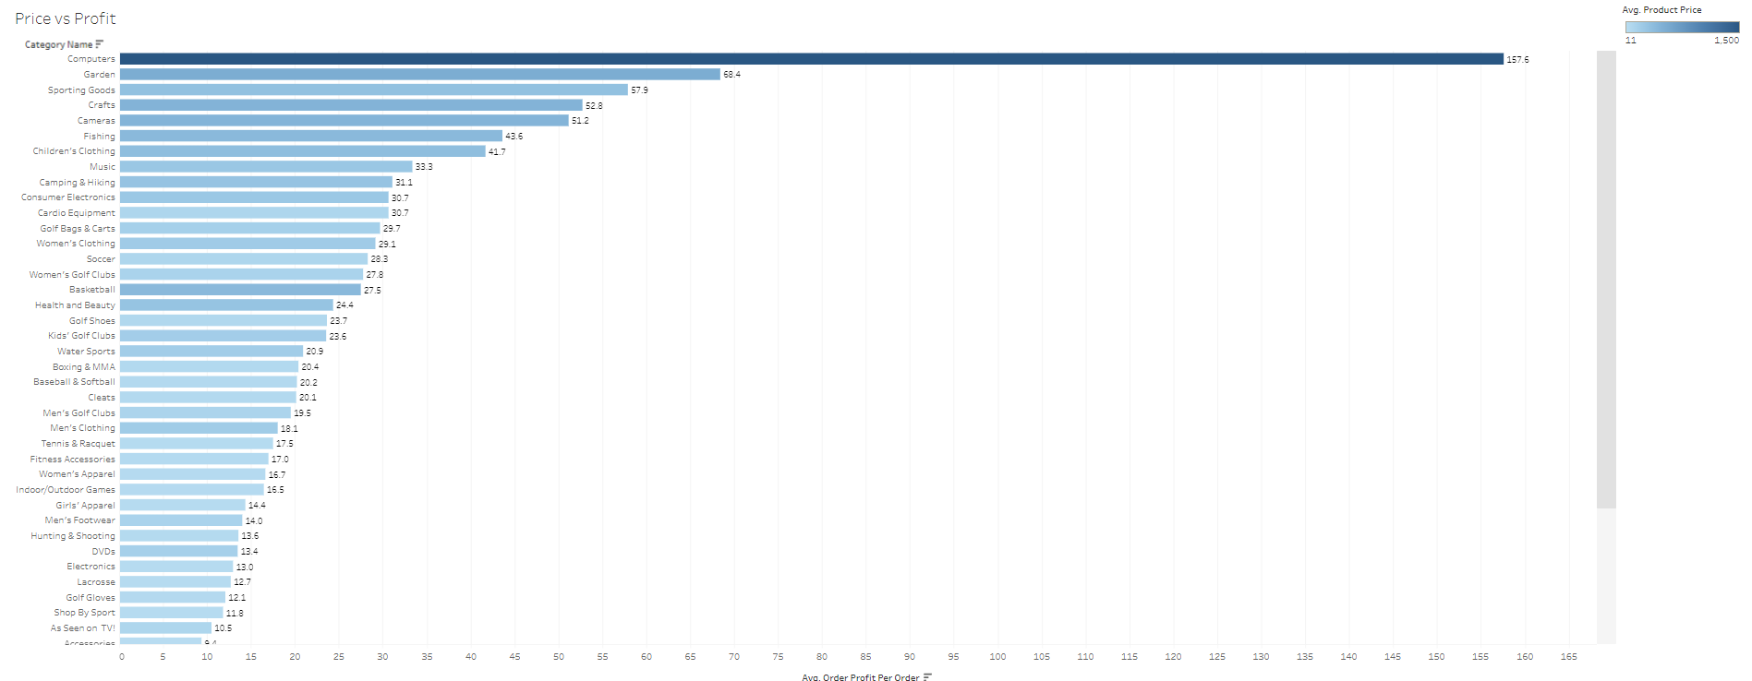

The graph shows the relationship between price and profit for different categories of products. The x-axis represents the order profit per order and the y-axis represents the category name. The highest order profit per order is for the Electronics category, followed by the Technology category. The lowest order profit per order is for the Books category. The main understanding of the graph is that there is a positive correlation between price and profit. This means that products with higher prices tend to have higher profits. However, there is also some variation in profit within each category.

**Sales Dashboard:**

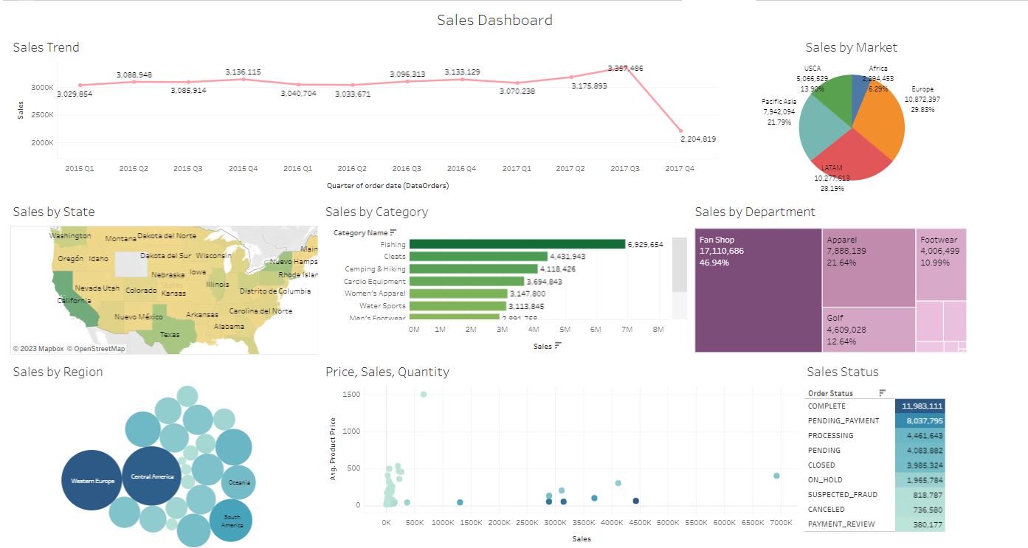

The company's sales have been increasing over time, with the highest sales in Q3 2017. The company's sales are concentrated in a few categories, with fishing accounting for over half of the company's sales. The company's sales are also concentrated in a few markets, with the Europe market accounting for the highest percentage of sales. The company's sales are highest for orders that are completed. The company is heavily reliant on the Europe and US market for its sales.

Recommendations:

The company can increase its sales by:

* Expanding into new categories and markets.
* Focusing on improving the customer experience.
* Investing in marketing and advertising.
* Offering competitive prices and discounts.

By taking these steps, the company can increase its sales and profitability.

The Dashboard shows that the company's sales are concentrated in a few states in the United States, with California, Texas, and New York accounting for over 25% of total sales. The company could focus on expanding its sales in other states, such as Florida, Illinois, and Pennsylvania. The image also shows that the company's sales are highest for orders that are completed. The company could focus on improving its order fulfillment process to reduce the number of cancelled orders. The company could also focus on increasing sales in the central asia market, which has the lowest sales of all the regions. The company could do this by offering competitive prices and discounts, or by investing in marketing and advertising in the region.

**Shipment Dashboard:**

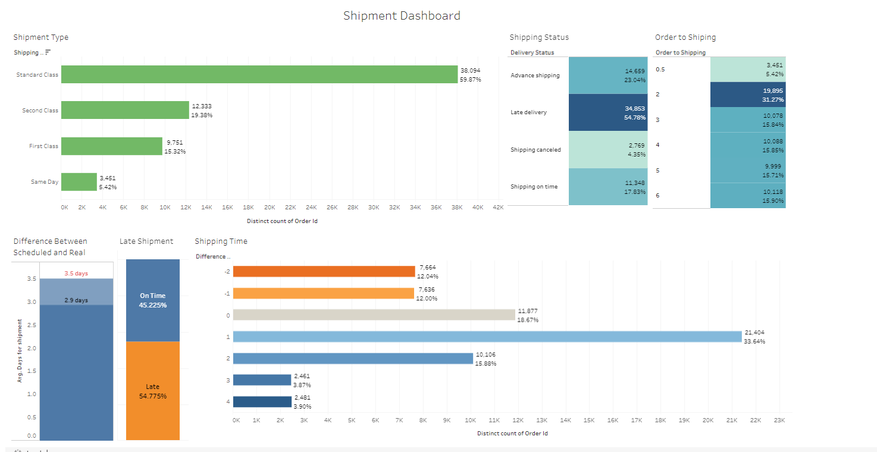

The graph shows the number of shipments for each shipment type. The most common shipment type is "Standard class", followed by "Second class". The least common shipment type is "Sameday". The average number of days of shipping is higher than the scheduled number of days. The highest difference between scheduled and real days of shipping is 3.5 days. This means that some orders are taking 7 days longer to ship than expected. The lowest difference between scheduled and real days of shipping is 0 days. This means that some orders are being shipped on time. The company is having difficulty meeting its shipping schedules. This could be due to a number of factors, such as high order volume, staffing shortages, or supply chain disruptions. The company should investigate the reasons for the delays and take steps to address them. The image shows the percentage of orders with each delivery status. The most common delivery status is "Late delivery", at 54.78%. The least common delivery status is "Shipping canceled", at 4.35%. The majority of orders are shipped within 1-3 days of being placed. However, there is a small percentage of orders that take longer to ship.

Recommendations:

The company can improve its shipping performance by:

* Identifying the root causes of shipping delays and taking steps to address them.
* Communicating with customers about shipping delays and providing them with updates on the status of their orders.
* Offering customers expedited shipping options at a discounted rate.
* Consider using a third-party logistics (3PL) provider to help with shipping and fulfillment.

**Profit Dashboard:**

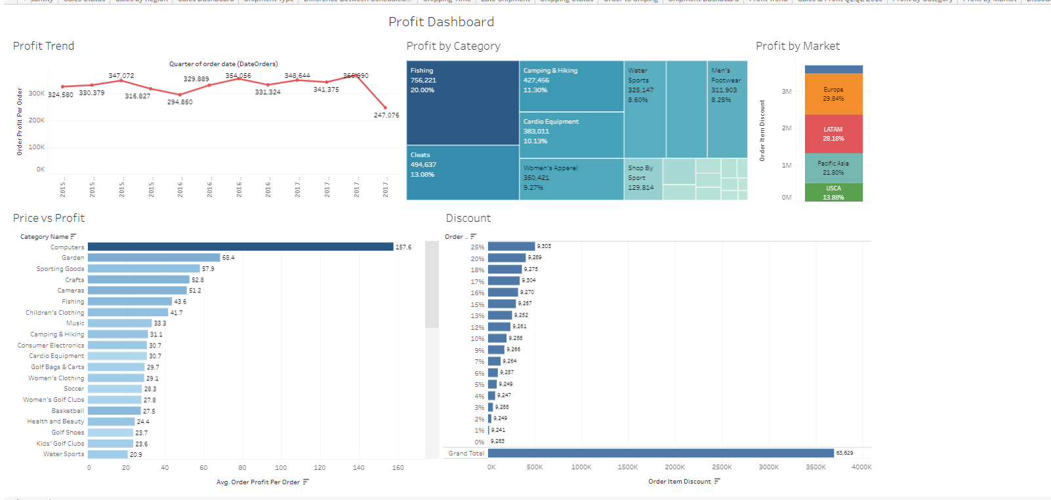

The first graph shows the profit trend over time. The highest profit per order is in Q3, and the lowest profit per order is in Q4. This could be due to a number of factors, such as seasonal fluctuations in demand, changes in marketing and advertising spend, or changes in costs. The second graph shows the profit by category. The most profitable category is the Fishing category. The Fishing category accounts for 20% of the company's total order profit, even though it only accounts for 756,221 of the company's total orders. This means that the Fishing category has a higher profit margin than the other categories. The third graph shows the profit by market. The most profitable market is the Europe market. The Europe market accounts for 29.84% of the company's total order item discount. The fourth graph shows the distribution of discounts for orders. The most common discount is the 25% discount. The fifth graph shows the relationship between price and profit for different categories of products. There is a positive correlation between price and profit. This means that products with higher prices tend to have higher profits.

Recommendations:

* The company should focus on selling products from the Fishing and Electronics categories, as these categories have the highest order profit per order.
* The company should also focus on selling products in the Europe and North America markets, as these markets are the most profitable.
* The company should consider offering more discounts on higher-priced products.

**Conclusion:**

The company's sales are primarily concentrated in a few categories and markets, with the highest sales being for completed orders. The company is heavily reliant on the Europe and US markets. To increase sales, the company can expand into new categories and markets, focus on improving customer experience, invest in marketing and advertising, and offer competitive prices and discounts. To increase sales in the central Asia market, the company could offer competitive prices and discounts, or invest in marketing and advertising. Additionally, improving order fulfillment processes could reduce the number of cancelled orders. The North America market, which accounts for 30% of the total order item discount, is the most profitable, accounting for 20% of the company's total orders. To maximize profits, the company should investigate the reasons for most orders having discounts of 0 to 25%, offer discounts on orders larger than a certain size or include certain items, and offer discounts to customers who are new or have not placed an order in a while. The business is successful and can be made even better by branching out into new areas and categories, enhancing customer service, spending money on marketing and advertising, and providing competitive rates and special offers.

# Reference:

1. Constante, F., Silva, F., & Pereira, A. (2019). DataCo SMART SUPPLY CHAIN FOR BIG DATA ANALYSIS (Version 5) [Data set]. Mendeley Data. <https://doi.org/10.17632/8gx2fvg2k6.5>
2. Seyedan, Mahya, & Mafakheri, Fereshteh. (2020). Predictive Big Data Analytics for Supply Chain Demand Forecasting: Methods, Applications, and Research Opportunities. ResearchGate. [https://www.researchgate.net/publication/346049822_Predictive_Big_Data_Analytics_for_Supply_Chai](https://www.researchgate.net/publication/346049822_Predictive_Big_Data_Analytics_for_Supply_Chain_Demand_Forecasting_Methods_Applications_and_Research_Opportunities) [n_Demand_Forecasting_Methods_Applications_and_Research_Opportunities](https://www.researchgate.net/publication/346049822_Predictive_Big_Data_Analytics_for_Supply_Chain_Demand_Forecasting_Methods_Applications_and_Research_Opportunities)
3. Seyedan, M., & Mafakheri, F. (2020). Predictive big data analytics for supply chain demand forecasting: Methods, applications, and research opportunities. Journal of Big Data, 7. <https://doi.org/10.1186/s40537-020-00329-2>
4. Mikalef, P., Boura, M., Lekakos, G., & Krogstie, J. (2020). The role of information governance in big data analytics driven innovation. Information & Management, 57(7), 103361. [https://doi.org/10.1016/j.im.2020.103361.](https://doi.org/10.1016/j.im.2020.103361)
5. Lee, I., & Mangalaraj, G. (2022). Big Data Analytics in Supply Chain Management: A Systematic Literature Review and Research Directions. *Big Data Cogn. Comput.*, 6(1), 17. <https://doi.org/10.3390/bdcc6010017>